**Incidence and Outcomes of Acute Circulatory Support Prior to Heart Transplantation**

**Background**: Proposed changes to the UNOS heart allocation protocol would prioritize patients with acute circulatory support, including extracorporeal membrane oxygenation (ECMO), percutaneous ventricular assist devices (PVAD), and intra-aortic balloon pumps (IABP). We sought to evaluate contemporary trends in the incidence and outcomes of acute circulatory support during the hospitalization prior to heart transplantation.

**Methods**: From the Nationwide Inpatient Sample (NIS) from 1998 to 2011, we identified 5,381 patients who underwent orthotopic heart transplant (OHT) and determined whether the patient underwent pre-transplant ECMO, PVAD, or IABP. We calculated baseline characteristics and time trends in each subgroup.

**Results**: Of patients who underwent heart transplantation, 586 (10.9%) were supported pre-transplant by IABP, 110 (2.0%) were supported by PVAD, and 102 (1.9%) were supported prior to transplant by ECMO. The utilization of PVAD prior to transplant increased over time (p-value for trend = 0.002) with 70% of PVADs in the last four years of the cohort. The overall utilization of acute circulatory support, IABP, ECMO, and the number of transplants did not change over time. The rate of survival to discharge was significantly lower in patients with ECMO (88.2%), PVAD (85.5%), and IABP (81.9%) compared to patients without acute circulatory support (95.9%, p < 0.001 for all comparisons). Patients who received acute circulatory support prior to transplant were slightly older (48.7 vs. 46.1 years old, p < 0.001) and had a higher number of comorbid conditions (12.1 vs. 10.7 diagnoses, p < 0.001).

**Conclusions**: In this cohort, we found that a significant proportion of patients received acute circulatory support prior to heart transplantation, with the use of PVAD support increasing over time. These patients exhibited significantly increased inpatient mortality compared to those without acute circulatory support. Changes to the UNOS heart allocation protocol should take both this increased mortality and the trend of increased PVAD use over time into consideration.

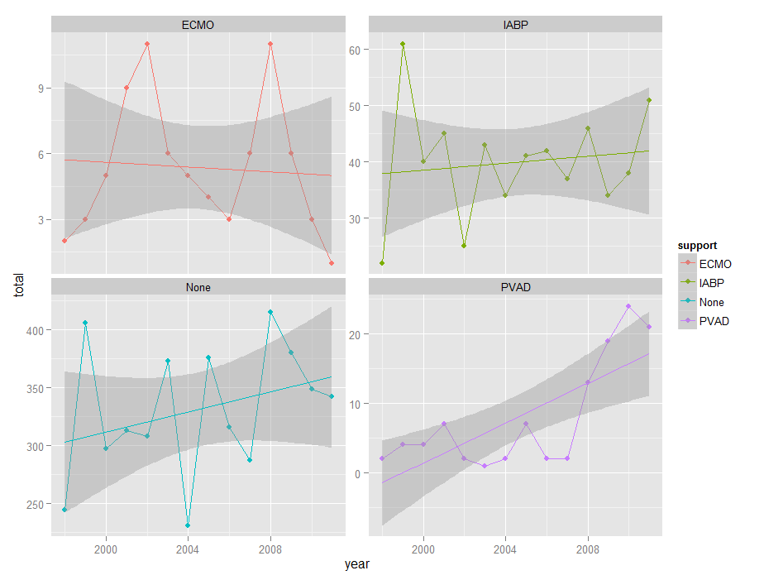

|  |  |  |  |  |  |
| --- | --- | --- | --- | --- | --- |
| Table 1. Baseline characteristics of patients who undergo heart transplantation subsetted by the utilization of acute circulatory support | | | | | |
|  | **None**  **n = 4637** | **IABP**  **n = 586** | **PVAD**  **n = 110** | **ECMO**  **n = 102** | **Total**  **n = 5381** |
| Length of stay, mean ± SD | 39.8 ± 48.4 | 56.4 ± 50.7 | 60.5 ± 56.8 | 88.5 ± 62.1 | 42.7 ± 498 |
| Mortality, n (%) | 223 (4.8) | 106 (18.1) | 16 (14.5) | 12 (11.8) | 350 (6.5) |
| Age, mean ± SD | 46.2 ± 18.9 | 51.6 ± 13.1 | 43.2 ± 21.4 | 37.4 ± 21.2 | 46.5 ± 18.6 |
| Sex, n (%) | | | | | |
| Male | 3370 (72.7) | 433 (73.9) | 83 (75.5) | 74 (72.5) | 3917 (72.8) |
| Female | 1266 (27.3) | 153 (24.5) | 27 (27.5) | 28 (27.5) | 1463 (27.2) |
| Race, n (%) | | | | | |
| White | 2638(56.9) | 325 (55.5) | 63 (57.3) | 57 (55.9) | 3050 (56.7) |
| Black | 587 (12.7) | 70 (11.9) | 22 (20.0) | 14 (13.7) | 680 (12.6) |
| Hispanic | 355 (7.7) | 39 (6.7) | 16 (14.5) | 15 (14.7) | 420 (7.8) |
| Asian/Pacific Islander | 109 (2.4) | 17 (2.9) | 4 (3.6) | 4 (3.9) | 133 (2.5) |
| Native American | 11 (0.2) | 5 (0.9) | 0 (0.0) | 0 (0.0) | 16 (0.3) |
| Other or unknown | 937 (18.5) | 130 (22.1) | 5 (3.8) | 12 (11.8) | 1082 (18.2) |
| Median household income, n (%) | | | | | |
| $1-24,999 | 735 (15.9) | 84 (14.3) | 26 (23.6) | 15 (14.7) | 850 (15.8) |
| $25,000-34,999 | 1074 (23.2) | 149 (25.4) | 27 (24.5) | 27 (26.5) | 1261 (23.4) |
| $35,000-44,999 | 1238 (26.7) | 142 (24.2) | 25 (22.7) | 27 (26.5) | 1419 (26.4) |
| $45,000 or more | 1463 (31.6) | 201 (34.3) | 30 (27.3) | 32 (32.4) | 1711 (31.8) |
| Unknown | 127 (2.7) | 10 (1.7) | 2 (1.8) | 1 (1.0) | 140 (2.6) |
| Comorbidities | | | | | |
| Diabetes | 870 (18.8) | 83 (14.2) | 19 (17.3) | 11 (10.8) | 977 (18.2) |
| Hyperlipidemia | 777 (16.8) | 42 (7.2) | 14 (12.7) | 9 (8.8) | 838 15.6) |
| Hypertension | 954 (20.6) | 69 (11.8) | 12 (10.9) | 8 (7.8) | 1039 (19.3) |
| History of smoking | 286 (6.2) | 20 (3.4) | 3 (2.7) | 4 (3.9) | 311 (5.8) |
| BMI ≥ 30 kg/m2 | 122 (2.6) | 10 (1.7) | 4 (3.6) | 2 (2.0) | 137 (2.5) |
|  |  |  |  |  |  |
| Number of comorbid diagnoses, mean ± SD | 10.7 ± 3.4 | 11.8 ± 3.0 | 13.9 ± 2.1 | 12.6 ± 3.0 | 10.86 ± 3.4 |

SD, Standard Deviation; BMI, Body Mass Index; ECMO, extracorporeal membrane oxygenation; PVAD, percutaneous ventricular assist devices; IABP, intra-aortic balloon pump.